Order Received-Shipped, Donated or Delivered

Here is what you need to know about orders your Girl Scouts might have received.

Shipped/Donated orders:


In eBudde you can look on the Girl Orders tab to see how many boxes each girl has sold. You do not need to provide any inventory to her for those orders.
You will see a credit for the full amount paid for those orders.

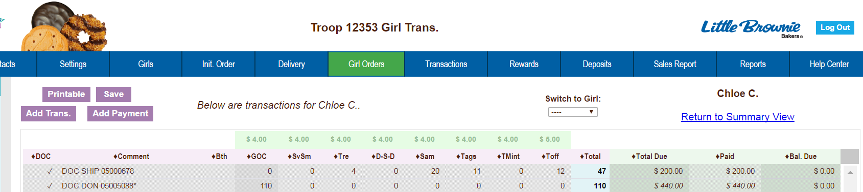
Shipped Order

Number of boxes

Amount Paid


You can also see the amount as a Deposit in your Deposits tab in eBudde.

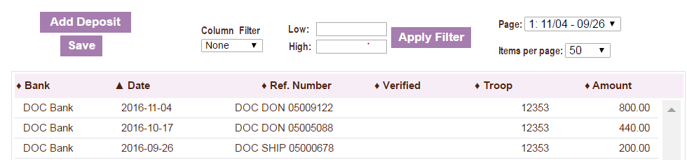


You may need to adjust the amount of money you deposit using the sales report as a guide. OR If your council has ACH withdrawals they will adjust to reflect that deposit already being made into your account.
DOC Ship/Donate orders reflect in “Pkgs Received”

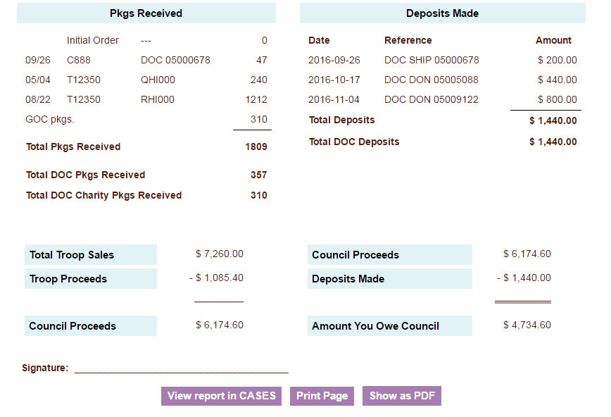
ALL DOC orders reflect in “Deposits Made”

All Digital Cookie sales will add to your troop’s total cookies sold and each girl’s total cookies sold. They will be reflected in your Sales and Per Girl Average and count towards any rewards the girl may be eligible to receive.

Delivered Orders:
NOTE: This is for orders after your council’s initial order. Cookies ordered for In-Person delivery prior to the council’s initial order will be reflected in the girl’s initial order in eBudde. Please see your council’s eBudde resources for more information.
On your Digital Order Card troop dashboard you can see if any of your girls have pending orders. (See “Troop Dashboard” for more info)

When the parent approves the order, the amount the customer paid will show as a credit on the girl order tab for that girl. NOTE-it does NOT automatically assign cookies for delivered orders to the girl. You will check cookies out for all orders she needs to deliver the same way you do for traditional deliveries. In-person delivery orders are essentially a deposit only.

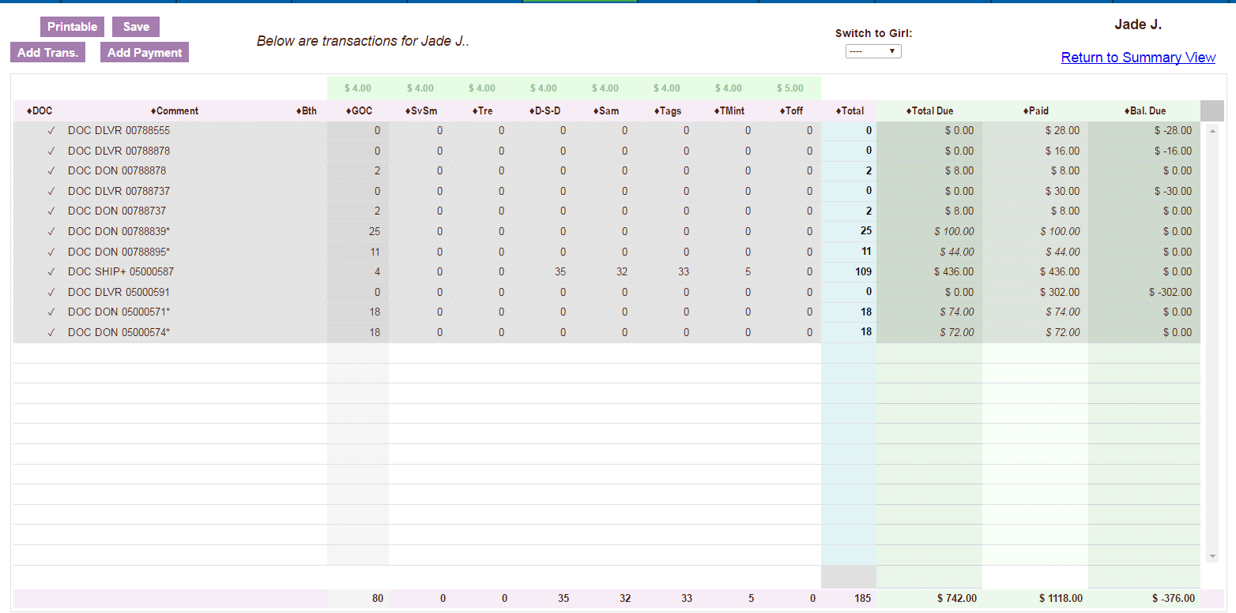
Amount paid for approved In-Person order

No inventory automatically assigned

(See Shipped & Donated orders for a view of the payment screens)

- The amount the customer paid will also reflect in your deposit tab in eBudde.
- You will need to adjust the amount of money you deposit using the sales report as a guide. OR If your council has ACH withdrawals they will adjust to reflect the deposit already being made into your account.

